1. **Which are the top three variables in your model which contribute most towards the probability of a lead getting converted?**
2. Below is the summary of the final model.

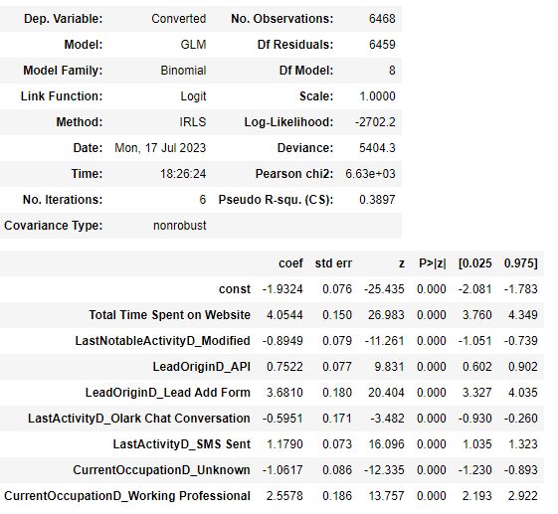

By this we can say, Total Time Spent on Website, Lead Add Form (Lead Origin) and Working Professional (Current Occupation) are the top 3 features that contribute to converting a lead.

1. What are the top 3 categorical/dummy variables in the model which should be focused the most on in order to increase the probability of lead conversion?
2. By seeing the model summary of final model, we can say, Lead Add Form (Lead Origin) and Working Professional (Current Occupation) and SMS Sent (Last Activity) are the top 3 dummy variables that should be focused the most on in order to increase the probability of lead conversion.
3. X Education has a period of 2 months every year during which they hire some interns. The sales team, in particular, has around 10 interns allotted to them. So during this phase, they wish to make the lead conversion more aggressive. So they want almost all of the potential leads (i.e. the customers who have been predicted as 1 by the model) to be converted and hence, want to make phone calls to as much of such people as possible. Suggest a good strategy they should employ at this stage.
4. Since optimal cut off that we saw was 0.38

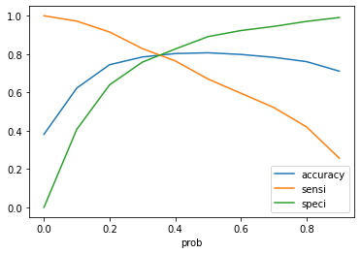

In order to make the sales aggressive, the company has to contact all the leads which have a conversion probability (value = 1) under a cut off 0.38 (column 0.3 highlighted).

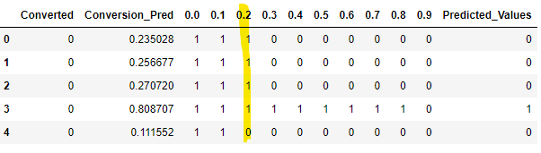

1. Similarly, at times, the company reaches its target for a quarter before the deadline. During this time, the company wants the sales team to focus on some new work as well. So during this time, the company’s aim is to not make phone calls unless it’s extremely necessary, i.e. they want to minimize the rate of useless phone calls. Suggest a strategy they should employ at this stage.

A- To minimize the rate of useless phone calls, the company has to contact all the leads

which have conversion probability 1 under 0.7 column as cut off is 0.38.

